# *Web Programming I (420-C10-HR)*

# *Lab 3 –HTML5 (The hard way)*

Date assigned: Tuesday, September 8, 2015

Date due: **Tuesday, September 8, 2015 end of lab**

**Learning Objectives**

Upon successful completion of this lab exercise, the student will be able to:

* Create a simple HTML Web page using a text editor
* View a web page in a browser
* View source code from inside the browser
* Edit the source code for a web page

To do:

**Lab Set-Up**

1. Create a folder named **YourUserName_C10_L03_html** in your H:\420-C10\Labs folder.
2. Save this document with the name **YourUserName_C10_L03_html.docx** in the folder created in the previous step.
3. You do not have to do the sections marked as BONUS MARKS. If you do they will be marked and marks will be added to your mark on the lab up to a total of 100%. If you do not do the bonuses you will not lose any marks.

**Part A – Writing HTML Snippets**

**For this section write the lines of HTML used to answer the questions. You must use good standards when writing the HTML (close all tags, always use lower case, etc). The templatehtml5.html linked to the Moodle page is the template for HTML5 files. You can copy and use this file as a template for the questions in this lab. Use the template to create a SINGLE html file which answers the following questions (that is, include the answers to all questions in the same HTML file). The filename must be a_textbook.html.**

Answer questions 1, 3, 4 and 5 in the Hands-On Exercises on page 64 of your textbook. Write your answers directly in this document.

**Part B – Writing HTML Web Pages**

**Make another copy of the templatehtml5.html**

1. Open Notepad++ by selecting Start, All Programs, Notepad++, Notepad++ **OR** Notepad, by selecting Start, All Programs, Accessories, Notepad.
   1. **Open** the HTML5 template file.
   2. **Type** inbetween the <body> and </body> tags the following lines to create a heading and 3 paragraphs:

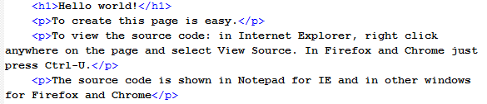

Figure 1: Source for b1_yourusername.html

* 1. Change the <title> element to be “My First Web Page by yourname”. Replace yourname with your actual first name and do not include the quotes.
  2. From the menu, select Files, Save As and save the file as **b1_YourUserName.html** in the folder you created for this lab.
  3. To see what you have created, you must view the document in a browser.
     1. Either double click the file you just saved to invoke the default browser or open your favourite browser. If you opened the browser without double clicking the file, type in the address bar the path to the file you just saved. The page displays using the default fonts for the browser you chose.
     2. If the page does not display correctly, make the required changes so that it displays as follows, including the title bar:

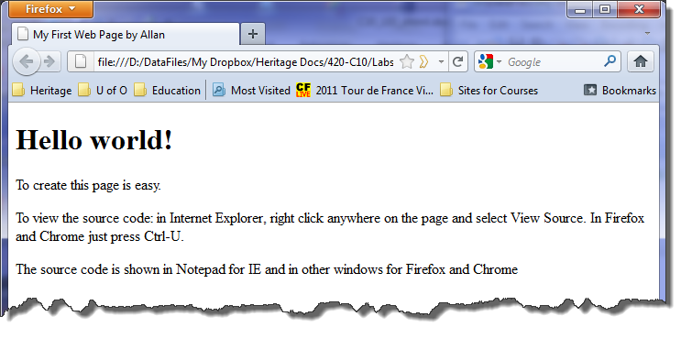

Figure 2: b1_yourusername.html

1. Select **File, Save As** to save the file as **b2_YourUserName.html** in the folder you created for the lab. DO NOT OVERWRITE the file created previously.
   1. Edit the source code as follows:
      1. Delete the 3 paragraph elements.
      2. Type “<p>I wrote this page using a Text Editor.</p>” below the “Hello, World!” line.
      3. Change the title to be “My Second Web Page by yourname”. Replace yourname with your actual first name and do not include the quotes.
   2. View the new page in your favourite browser by changing the URL in the address bar to reference the YourUserName_html_2.html file. Press the Enter key or the Go button. The revised document will be loaded in the browser window.
   3. If the page does not display correctly, make the required changes so that it displays properly.
2. Use Notepad++ (or Notepad) to create a new web page like the one in the figure below (as displayed in Internet Explorer). Save the page as **b3_YourUserName.html** in the folder you created for this lab. Replace “Your Name” with your own name in both the title and the name at the bottom. Add spacing and indentation to make the code easy to read and follow.

The website <http://validator.w3.org/#validate_by_input> is used to validate html code and make sure that it meets the HTML5 (or other) standard. In your editor (Notepad++ or other) click Ctrl-A to select all the text and then Ctrl-C to copy the text. Go to the website <http://validator.w3.org/#validate_by_input> and paste the text (Ctrl-V) into the text box there. Press the check button and make sure that your page does not have any HTML5 errors.

The page uses the following tags:

Title: Your Name’s nested list page

Heading1: Internet Browsers and HTML Editors

Paragraph: This document lists current Internet browsers and HTML editors using nested lists.

Horizontal Rule (tag is <hr />)

Description List, with description terms: Browsers in order of popularity, HTML editors

Description Definition for the first item, with a nested Ordered List: Mozilla Firefox, Google Chrome, Microsoft Internet Explorer, Apple Safari, Opera

Description Definition, for the second item, with a nested Unordered List: – WYSIWYG, non-WYSIWYG

Unordered List (under WYSIWYG): Adobe Dreamweaver, Microsoft Expression Web, Joomla, Bluefish

Unordered List (under non-WYSIWYG): Notepad++, Notepad, Sublime

Horizontal Rule

Paragraph: Your Name, Mailing Address of the school

Line Break: End of each of the address lines with a line break

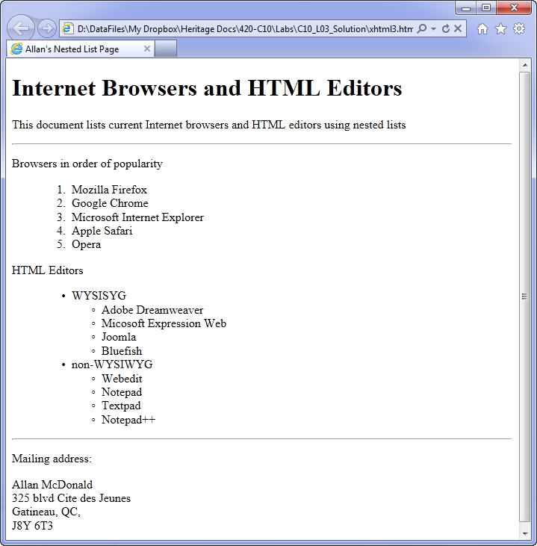

Figure 3: b3_yourusername.html

1. Save the file as file as b4_yourusername.html. Before the end of the Description List, add the following tags and contents:
   1. Description term: Document Type Definitions in XHTML 1.0

Description definition: an unordered list with the names of the 3 doctypes valid for XHTML 1.0 (Refer to the class notes on doctype or <http://www.w3schools.com/tags/tag_doctype.asp> for the 3 names to be included in the unordered list).

* 1. Validate your page using the link <http://validator.w3.org/>, a Markup Validation Service, by copying the code from the file and pasting it in the **Validate by Direct Input** text area or by loading the file up to the validator as per the instructions on the validation web page. Make any changes identified by the validation service. Re-run the validation service until there are no errors. Save the corrected file.
  2. Note: You will receive probably three warnings in doing the validation; these are okay. Once you have validated the page (no errors) check your textbook and include the proper tag to remove one of the three warnings (the second one actually).

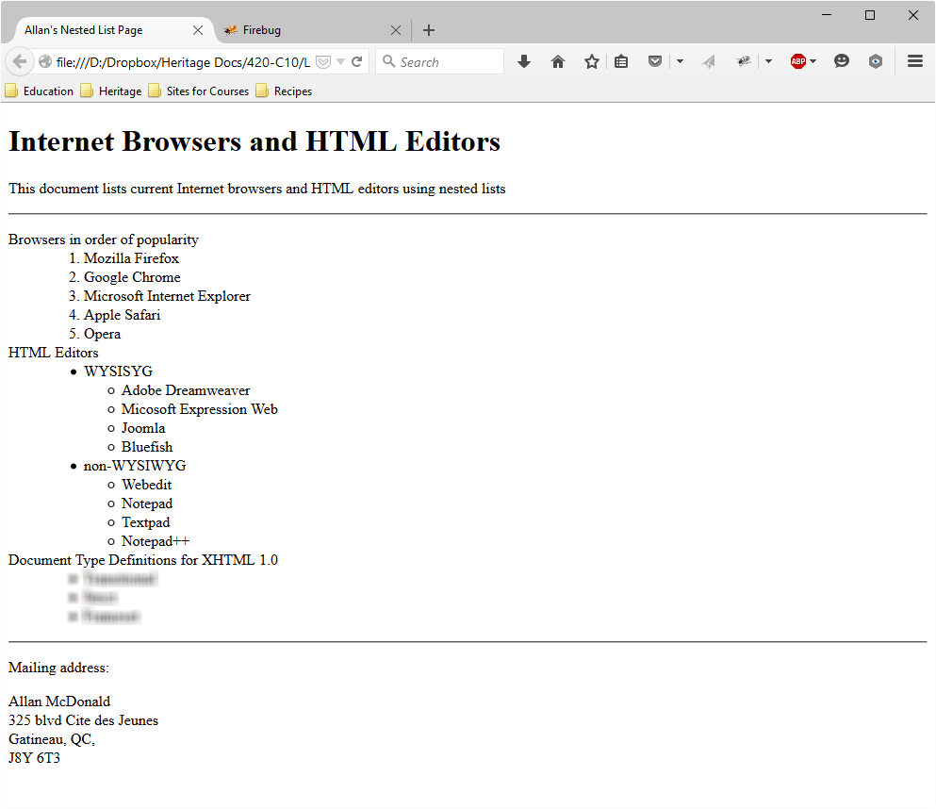

Figure 4: b4_yourusername.html

1. Answer questions 8 and 9 in the Hands-On Exercises from page 64 of your textbook. These web pages MUST BE HTML5 compliant so use the template. Prefix the filename in the instructions with the question name and your username (b9_YourUserName_band.html).
   1. For Question 8 do NOT worry about the hyperlink. If you want to figure it out by yourself you can do it, but we have not yet learned that. Filename is b8_yourusername_network.html
   2. For Question 9; Nickelback is NOT a music group ;-). File name is b9_yourusername_band.html)

**To submit**

When you have completed the lab exercise, create a zip file of the YourUserName_C10_L03_html folder, containing the following:

* a_textbook.html
* b1_YourUserName.html
* b2_YourUserName.html
* b3_YourUserName.html
* b4_YourUserName.html
* b8_YourUserName_networks.html
* b9_YourUserName_band.html